- We expect the Monetary Policy Committee to keep Bank Rate at 4.5% at its next meeting on March 20. The cut-hold tempo has become well established and renewed concerns about supply weakness mean it's very unlikely there will be more than two or three votes for back-to-back cuts. The only real uncertainty is whether Alan Taylor will vote to cut again.
- Though the messaging from the February meeting was surprisingly hawkish, subsequent soundings from individual committee members have been more balanced. Even the most hawkish members have suggested the MPC's mid-range inflation scenario is most likely to play out. This scenario is consistent with rate cuts at alternate meetings.
The Bank of England's Monetary Policy Committee cut Bank Rate by 25bps at its last meeting on February 6. Though the outcome was in line with expectations, there were two surprises. First, Catherine Mann's sudden switch from being the most hawkish member to among the most dovish. And second, the surprisingly hawkish tone of the MPC's messaging, which argued that weak supply meant the growth-inflation trade-off had worsened.
Most MPC members have subsequently made public comments, but only two have materially changed their views (Table 1 shows our analysis of recent comments by MPC members). Catherine Mann expanded on her volte-face, arguing survey evidence suggested there could be a "non-linear" fall in labour demand in response to a series of large cost increases. In contrast, Dave Ramsden moved back into the pack, having briefly flirted with dovish dissent in December. Ramsden now thinks the risks are two-sided, having previously argued domestic disinflationary pressures would be stronger.
The MPC largely sidelined its inflation scenarios in its communications around the February meeting, but individual members have made liberal use of them in their comments since. We estimate that seven members see the mid-range scenario as most likely to play out, with one of those leaning dovish (Alan Taylor), and two concerned that supply weakness will cause pay growth and inflation to remain higher for longer (Huw Pill and Megan Greene; Chart 1).
Chart 1: Most MPC members still think the mid-range inflation scenario is most likely to play out
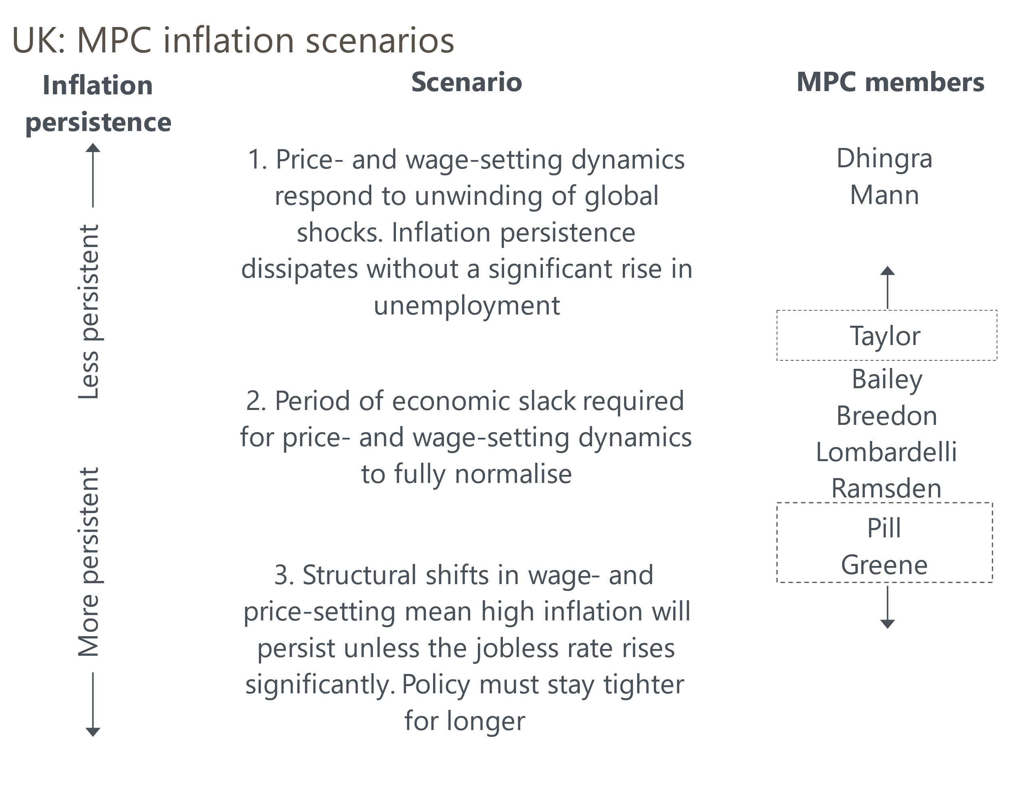
Source: Oxford Economics

Table 1: Key comments by MPC members since the February meeting
Speaker and link | Date | Key takeaway
Mann | March 6 | Mann said her switch from hawk to dove was in response to business survey data suggesting a "non-linear downward adjustment" for labour demand in response to rising labour costs.
Bailey | March 5 | Appearing before the Treasury Select Committee, the Governor said, "the demand weakness argument may be getting a bit stronger relative to last year" and emphasised the underlying path for inflation was still downwards.
Pill | March 5 | The BoE's Chief Economist remarked that the "continued weakness in productivity growth and wider disruptions to the economy's supply-side were perpetuating the persistence of price and wage developments".
Taylor | March 5 | Taylor argued that the fall in inflation last year occurring alongside a slowdown in activity was "first-order evidence that the shock to demand was dominating". He also said the current output gap is probably larger than the estimate in February's Monetary Policy Report.
Greene | March 5 | Greene offered a similar view to Pill, arguing the recent uptick in measures of private sector earnings growth, food price inflation, and core goods prices were indicative of an economy that is primarily supply-constrained.
Ramsden | February 28 | After flirting with the dovish camp in December, Ramsden has reverted to the middle of the pack. Though the core disinflationary process remains intact, he argued the risks are now "two-sided".
Dhingra | February 24 | Dhingra argued that "demand is generally weak" and said the "consumption weakness is just not going away".
Source: Oxford Economics
The MPC's middle scenario is broadly consistent with maintaining the cut-hold tempo. It follows, therefore, that the majority will vote to hold Bank Rate at 4.5% next week. From our perspective, the only real question mark is whether Taylor votes to cut. He voted for back-to-back cuts in December, and his recent testimony to the Treasury Select Committee made clear that he thought weak demand was the dominant factor in the inflation outlook. However, he also cited concerns about the likely scale of regulated price rises in April and the recent strength of the official pay series. He characterised his February vote as steering a middle course through those factors; this time around the middle course is likely to be a vote to hold.

Recent data offer few new insights to the MPC
Data published since the last meeting have been mixed. January's reading for CPI inflation came in 0.2ppts above the BoE staff's forecast, but services inflation – a key signal of underlying pressures – came in 0.2ppts lower than anticipated.
Private sector regular pay growth of 6.2% in the three months to December was still well above the pace the MPC considers consistent with achieving the inflation target over the medium-term. But the official series for pay growth increasingly looks an outlier, with all other measures much softer.
The MPC will have exceptional pre-release access to the next set of labour market statistics (due to be published the morning that the MPC announces its decision), but a calendar quirk means it won’t see February's inflation data (due out on March 26).
Turning to demand, December's GDP outturn was much stronger than expected. But this followed a series of softer readings, and problems with residual seasonality make deriving a clear signal from activity data difficult. Business survey data remains subdued, but it's hard to separate dissatisfaction with the Budget and Trump-related uncertainty from actual trends in activity.

August is likely to be the next meeting with genuine jeopardy
At the recent Treasury Select Committee hearing, MPC members were at pains to stress the heightened degree of uncertainty, and Taylor remarked that "every meeting coming up for the MPC will be a live meeting". But we think the reality is somewhat different. Bank Rate is still well above all estimates of neutral, and unless there's a sudden, unexpected, change in the growth or inflation outlooks, we view a 25bps cut in May as almost certain.
Financial markets largely agree, pricing a 75% chance of a 25bps cut by the May meeting. Furthermore, though the MPC's most hawkish members, Pill and Greene, expressed concerns about supply weakness at the TSC hearing, they confirmed that the mid-range scenario remained their baseline and that they expected Bank Rate to continue to gradually fall.
Financial market developments since the February meeting support the gradual pace of rate cuts continuing. Gas and oil prices have dropped back, while sterling has strengthened against the dollar. This implies the pickup in inflation will be slightly more muted this summer than anticipated in the BoE's most recent forecast (Chart 2).
Chart 2: Financial market developments point to a lower peak for inflation
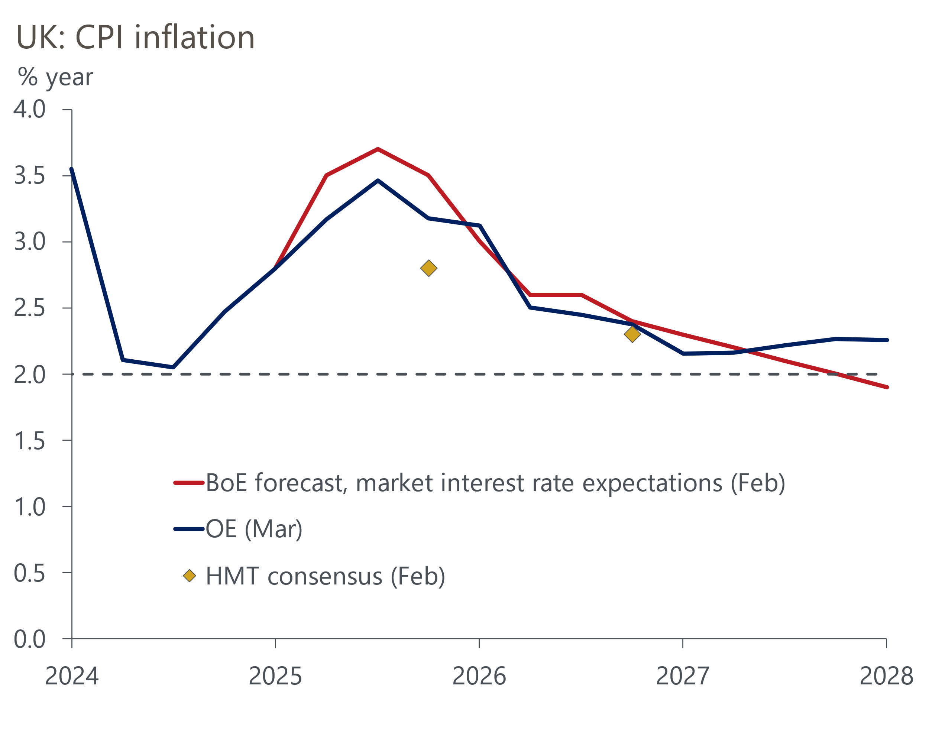
Sources: Oxford Economics, Bank of England, HMT
But the key influence on the BoE's forecasts – and the most obvious threat to the cut-hold tempo – will be evidence of the impact of April's increases in regulated prices, employers' national insurance contributions, and the national living wage. Indeed, Governor Bailey has identified the increase in NICs as a key source of domestic uncertainty on several occasions. Business surveys and April's inflation outturn will be available for the MPC's June meeting. But there will be scant official labour market data until the run up to the August meeting. The MPC will also update its forecasts then, so the August meeting is likely to be the next time there will be genuine jeopardy around the monetary policy decision.

